## Contact email

Will Dimeo - willdk11@yahoo.com

Desmon Fields - dfields012@gmail.com

Corey Herington - coreyherington87@msn.com

Jagoba “Jake” Marcos - jagoba.marcos@gmail.com

## Title

Ninja vs Zombies: the Pizza Deliveries

## Studio

Little Hydra  
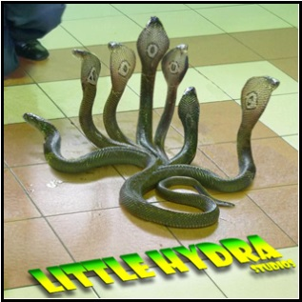

## Team

Don’t Ask Questions!



## Summary

NvZ is a stealth based puzzle game inspired by the ancient feudal Japan. The hero Kentaro Pankiji must explore a tower by using his grappling hook. This item allows him to grab objects or jump to objects and avoid traps or attacks

## The Hook

The hook of the game is the grappling hook and all its uses.  You can move to objects, move objects, and flip switches that unlock doors. It also can be used to pick up the pizza from afar

## Comparable products:

Gameplay:

* Camera view

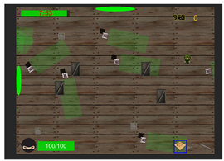

Our game will have top-down vie

* the hook

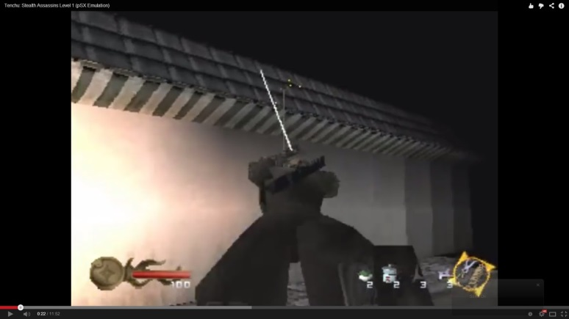

                 Like Tenchu game (two images above) our game will have a grappling hook

* Game flow

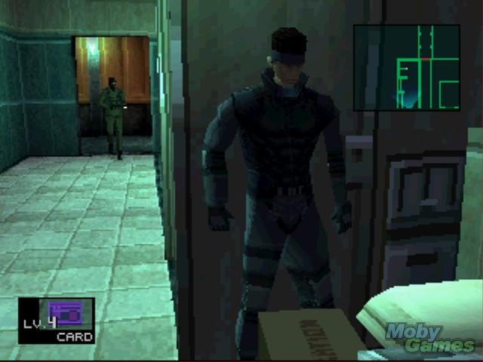

Like in Metal Gear Solid series, our game will have many ways to beat the level: stealth way focusing on having a low profile or “Rambo” mode which means killing all enemies (or try to do it)

* Puzzles

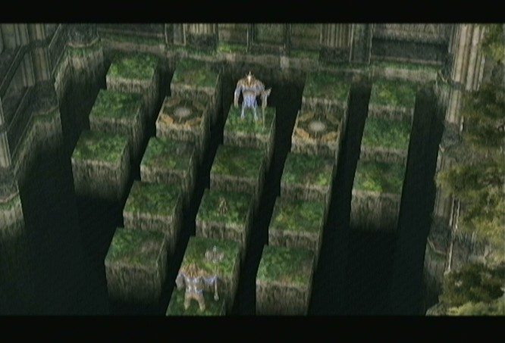

The Zelda series are very famous for their puzzles. Our game will also implement hard puzzles to challenge the player’s intelligence

* Maps

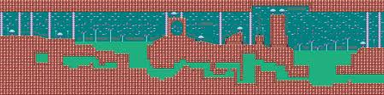

This image is from Sonic 2 (sega master system 2) in which shows a map with different paths.

Interface

* Timer

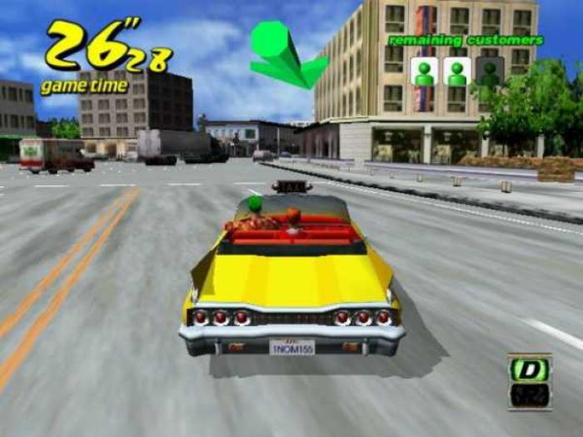

Crazy Taxi, example of a timer

* Health bar

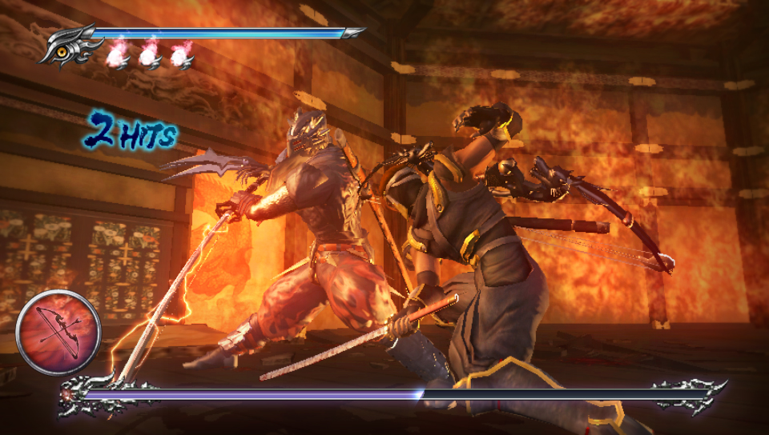

Ninja Gaiden, health bar example

* Alert indicator

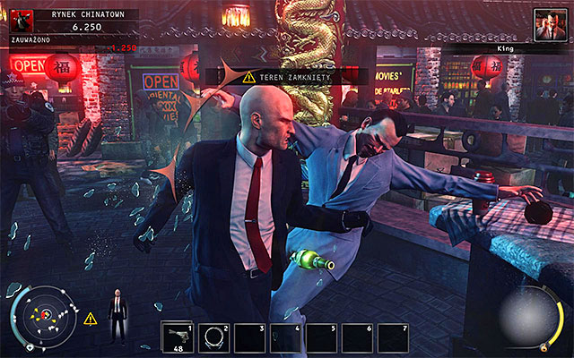

Hitman Absolution, if you attack an enemy you will alert the nearby enemies and also start the alert protocol

Art style

Characters

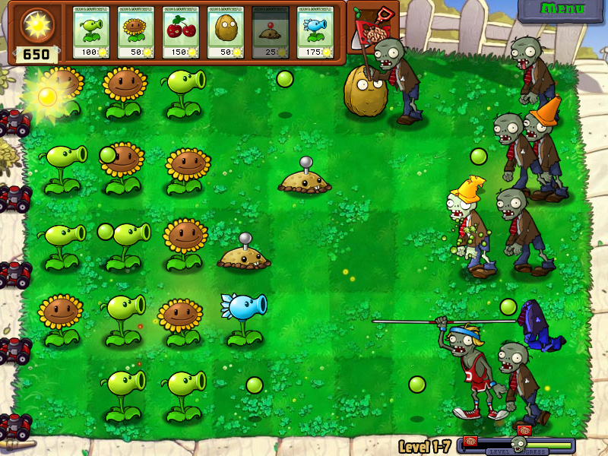

Plants vs Zombies, zombies design example

* Toppings and special items

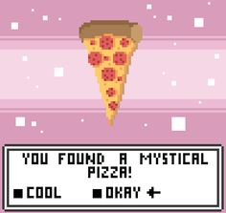

Message when player gets a topping or special item

* Boss

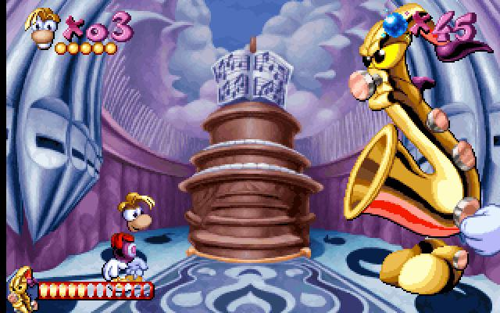

Rayman image. The boss level will be a separate room with a special hud and hot points which player will be able to interact with

## System list

Shop

* upgrade weapons and attributes - goto items/attributes
* currency
* smoke bombs - can upgrade

System

* item drops for levels - goto items
* AI/Behaviors -- different enemy team work modes
* HUD -- see interface section
* detection system
* enemy communication for working together (simple messages)
* camera will follow, sit still till time to move
* Pizza Fight
  + timer- look at enemies for stats
  + progress bar

Puzzles

* time based completion
* can damage or insta kill
* Sequential button presses
* moving objects to correct places
* levers -- activate/deactivate
* finding hidden doors

Characters Shared attributes (player can upgrade):

* Health
* Defense
* Strength
* Movement speed

## Pc

* take/drop pizza -- allows attacking
* slash and kill enemies with your sword
* smoke bomb for getaways
* can use traps to kill
* HOOK
  + ...to grab things
  + ...to travel to points
  + ...to activate levers
  + ...to attack enemies

## NPCs

* Normal zombie
  + move (slower than player)
  + attack( if player has pizza)
  + go to pizza
  + steal pizza
  + run away (has pizza)
* Ranged Ninjas:
  + throw shurikens

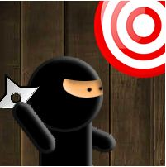

* Big “Boss” that chases you
  + attack
  + move
  + update room with move and attack
  + check for closer target.(player vs pizza)
  + eat pizza
* Armored Zombie:
  + move(slowest)
  + attack -- more damage and defense
  + steal pizza
  + run away(has pizza)
  + pulls player(if hooked)
* Ambush Ninja
  + hide inside or behind objects
  + steal pizza( when it is on the ground and player is away from it)
  + run away(has pizza)

## GamePlay Objects

* drop the pizza - to attack
* smoke bombs - to stealth
* find power ups - go to item section

## Terrain/Environment

* old medieval castle - style
* obstacles (header)
  + pitfalls
  + non-movable “big boxes”
  + timer
  + walls
  + doors
* secret doors/stairways
* puzzles - look for Puzzles section
* rooms - sections
* levers - activates traps
* traps - hurt player/boss/enemies
* spawn points - enemies
* midway checkpoints

## World Objectives

* toppings -- find toppings in the level
* breaking crates - possibly spawns coins or items
* potted plants to break/slash

## Interface

* HUD
  + Health bar
  + Timer
  + Item selector
  + Money counter
  + Item inventory
* Controls
  + Xbox Controller

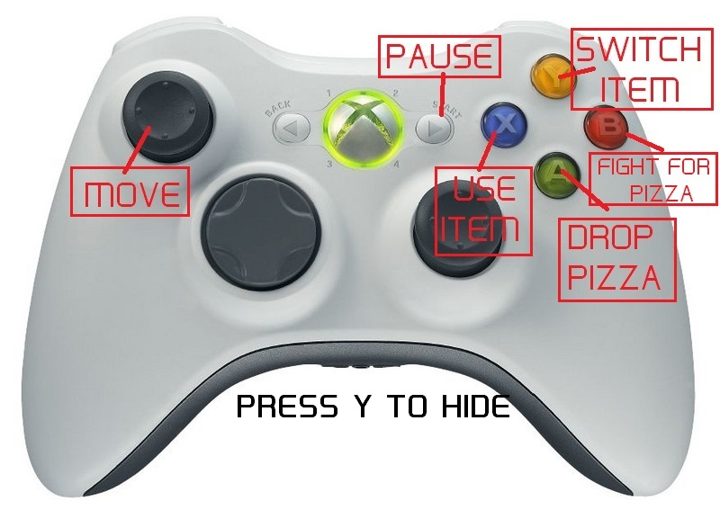

* + Keyboard

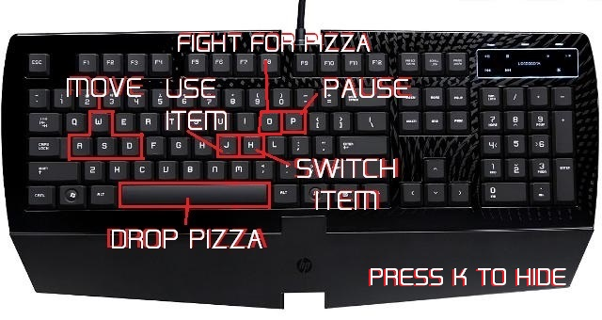

## Main Goals:

WIN

- Reach the end of the level with the pizza.

- Deliver the pizza in every level.

LOSE

- Pizza is stolen.

- Lose all HP (Hit Points)

## Provisional Goals

* different toppings in level upgrades(hidden).
* get a tip for delivering in faster times
* Upgrading items/weapons/skills
* Completing all puzzles within floor
* delivered on time streak bonus.
* Never lose your pizza
* Getting through the level
* Avoiding enemies
* defeating all enemies
* Finding different traps and items
* Solving all the puzzles
* finding all the toppings

## Items

* Smoke bomb
* Sword
* Grapple hook
* Power ups/Drop items
  + strength
  + defense
  + movement speed
  + health up
  + super ninja star

Boss

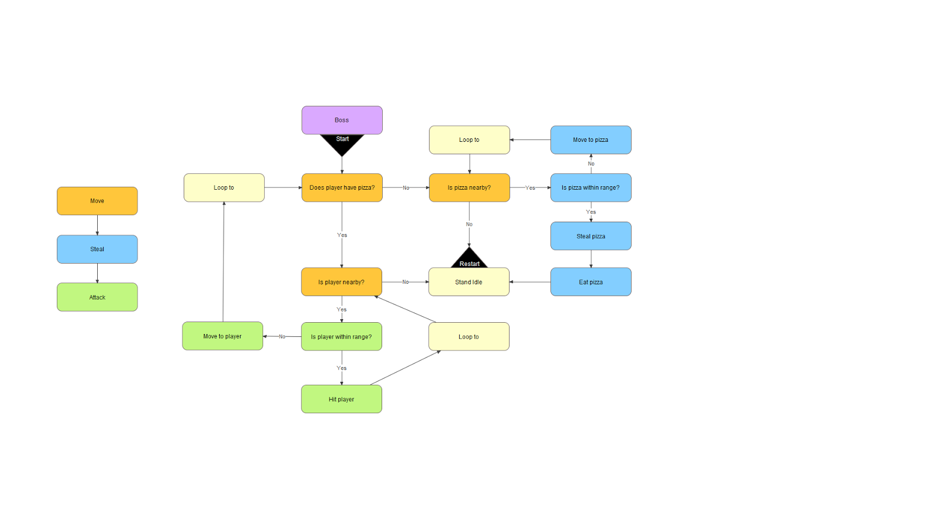

Zombie

